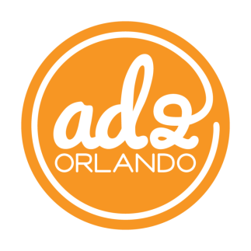
FOR IMMEDIATE RELEASE

Media Contact: Karissa Kennedy, Public Relations Chair
Email: PublicRelations@ad2orlando.org

AD 2 ORLANDO OPENS PUBLIC SERVICE CAMPAIGN FOR LOCAL NON-PROFITS
Local advertising club opens applications for pro bono integrated marketing services

ORLANDO, Fla., July 23, 2015 -- Ad 2 Orlando has announced their 2015-2016 public service campaign’s call for applications, the start of a process that will afford one Orlando-based non-profit pro bono marketing and advertising services.
The organization’s Public Service Committee, which has worked on behalf of Central Florida organizations such as Ribbon Riders and Jimmy Buffet’s Save the Manatee Club, volunteers thousands of hours towards the planning, development, and execution of the selected client’s integrated marketing communications campaign. Previous campaigns have been valued between $250,000 and $500,000 in volunteer hours and donated media.
“Our members join Ad 2 Orlando to grow professionally and put their skills to work here in Central Florida,” said Alicia Abbott, the organization’s Club President. “Helping these non-profits overcome financial obstacles to raise their voice and further their cause has been extremely rewarding.”
Applications are open to organizations who qualify for a 501(c)(3) tax status and must be submitted online via Ad 2 Orlando’s online portal by July 31, 2015 to receive consideration.
Since the early 1960s, Ad 2 chapters across the nation have been providing pro-bono advertising and marketing campaigns to non-profit organizations in their communities. The campaign must support a local, regional, or national service project in the public interest or designed for community betterment. Public Service campaigns are showcased for public viewing at the annual AAF National Conference. All campaigns are professionally produced and a team of judges selects the campaign that best served its community each year.

About Ad 2 Orlando
Ad 2 Orlando is the Central Florida chapter of the young professionals division of the American Advertising Federation. Ad 2 Orlando is comprised of young, ambitious individuals who would like to learn and grow in their integrated marketing career.

Related Links
http://ad2orlando.org/

###

